SPECIAL FORUM & EXBIHIBITION on

Challenges and Opportunities for Collaboration
European Union – Poland – Eastern Europe Countries
BEST OF EAST
November 28-30, 2011 WARSAW, Poland
GROMADA Airport Conference and Exhibition Centre

Including jubilee events

5th International Forum  Science & Technology Days Poland-East   | 5th International Forum  on Innovative Technologies  for Medicine  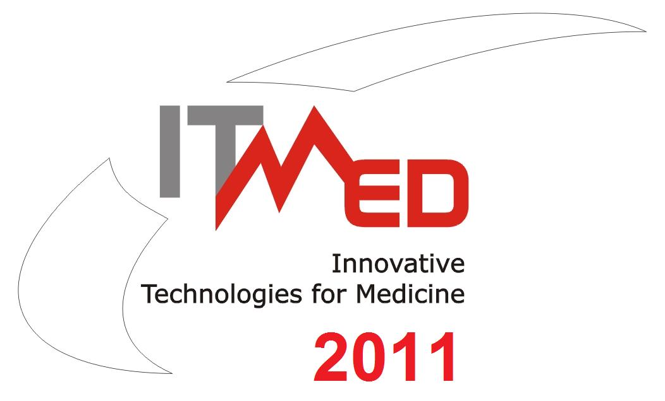

THE GOAL OF THE FORUM:
- promote and expand the international co-operation between EU countries, Poland and Eastern Countries with special focus on Eastern Partnership initiative and possibilities for collaboration in European Programmes 2014-2020
- undertake special business ventures based on the transfer of new technologies and corporate solutions, and preparing common projects ideas concerning programmes which are presently in progress (including 7.PR, EUREKA, Regional and Cross Border Cooperation Programmes)
- present the potential of Eastern Poland Regions – their fast development based on innovative business, people, academia, environment and traditions
- promote results achieved thanks to regional policy of development and wisdom of researchers and entrepreneurs from Poland and neighbor countries

THE FORUM IS ADDRESSED TO:
● innovative companies offering new technologies, innovative products
● R&D and technology transfer centres offering business proposals/offers for enterprises
● Business Environment Institutions

from EU and Eastern Europe countries, with special participation of Poland

THE FORUM WILL HOST:
SESSIONS  ● success stories  ● achievements of Eastern Poland Regions in implementing innovative projects financed by EU  ● research and business opportunities in very important and promising research topics: energy, rehabilitation, telemedicine  ● the most important and attractive directions of scientific research and possibilities of cooperation “Four Challenges for Europe”  CONTEST for Exhibitors’  for POSTER SESSION presentations | EXHIBITION  ● Partnering Meetings  ● Exposition presenting achievements and opportunities for collaboration: EU, Poland and Eastern Countries especially in areas:   Innovative Technologies for Medicine   Energy   Environment   New Materials and Processes   ICT   Transregional Cooperation  ROUND TABLE DISCUSSIONS on HOT TOPICS

ORGANIZERS:
● International Innovation Centre of East (IICoE) - Innovative Eastern Poland Association
in cooperation with Podlasie Region

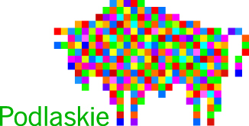
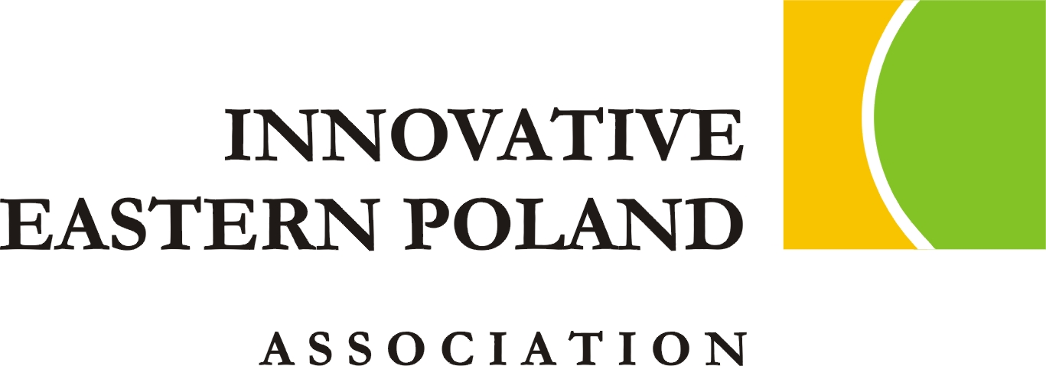

and (among others)

● National Contact Point for Research Programmes of the EU ● EUREKA Initiative Offices from Poland, Lithuania, Ukraine ● Belarusian Institute of System Analysis and Information Support of S&T Sphere (BelISA) ● Lviv Centre for Scientific Technical and Economic Information (LvCSTEI)

HISTORY:
SCIENCE & TECHNOLOGY DAYS POLAND EAST Forums:
October 2007, April 2009, April 2010, April 2011:

ITMED INTERNATIONAL FORUMS ON INNOVATIVE TECHNOLOGIES FOR MEDICINE:
May 2007, October 2008, December 2009, December 2010

SCIENCE & TECHNOLOGY DAYS POLAND EAST Forums and ITMED Forums gathered
- over 1000 participants from Poland, Ukraine, Belarus, Lithuania, Estonia, Latvia, Sweden and Belgium
- over 200 presentations
- over 200 brokerage-event meetings
- over 400 concrete proposals of cooperation in new projects or common economic ventures

Honorary Patronage:
● European Parliament ● Minister of Science and Higher Education ● Minister of Health ● Minister of Regional Development ● Minister of Economy ● Polish Agency for Enterprise Development ● The Marshal of the Podlaskie Voivodeship ● The City Mayor of Bialystok ● Voivode of Podlaskie Region

VENUE:
GROMADA Airport Conference and Exhibition Centre, Warsaw, 17 Stycznia Str. 32

SECRETARIAT:
International Innovation Centre of East (IICoE) - Innovative Eastern Poland Association,
7, Antoniukowska str., 15-740 Białystok, phone./fax: +48 85 675 00 95, mob.: +48 728 958 050
e-mail: dnt2011@ipw.org.pl www.ipw.org.pl skype: innowacyjna.polska.wschodnia

