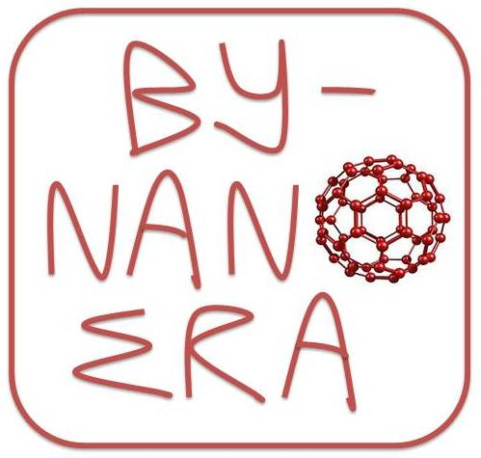
BY-NANOERA FP7 Trainings
Training Course 2
YOU ARE IN A CONSORTIUM:
obligations and requirements for a partner in FP7 project

Date: 18 October 2011
Location: Belarusian National Technical University (TBC)
Language: English (translation is not foreseen). All materials will be provided in English
Trainers: Olga Meerovskaya, Belarusian Institute of System Analysis and Information support of S&T sphere
Raphael Koumeri, Research & Innovation PLANET S.A., Greece

Draft Agenda
9:00  9:15  9:30  12.15 -  13.00  16.00 | Welcome and round-table presentation  Brief overview of the Training 1  FP7 project: from getting in a consortium to a project start – an overview of the cycle and timeframe. Roles of a coordinator and partners.  Part 1  What involvement and which information is needed from a partner at the proposal development and submission stages:  - Developing of a project idea (earlier involvement, active communication, task or WP leadership, etc)  - Registering a proposal in EPSS (EPSS, how it works, PIC)  - Drafting a proposal (part A, composition of a part B, partner profile)  - Calculation of a budget (rationale, distributing costs between categories, how to estimate personnel costs, lump sums, practical exercise)  - Pre-submission proposal check  - Submission and what happens after  - Wrap-up of the part 1  Lunch  Part 2  Evaluation: how it works, experience of a Belarusian evaluator  What involvement and which information is needed from a partner at the stage of developing a legal framework for a project implementation  - Grant agreement  - Consortium agreement  - IPR  Registration of a FP project in Belarus as precondition of its implementation: rules and tips  Experience of Belarusian team in FP with focus on involvement in a proposal development and project outcomes  Wrap-up of the part 2  Closure | All  Olga Meerovskaya  Raphael Koumeri  Raphael Koumeri  Raphael Koumeri  Raphael Koumeri  Olga Meerovskaya  Raphael Koumeri  Raphael Koumeri  Trainers  Anna Pobol  Olga Meerovskaya  Olga Meerovskaya  TBC  Trainers

Coffee breaks – appr. at 10.30 and 14.30

