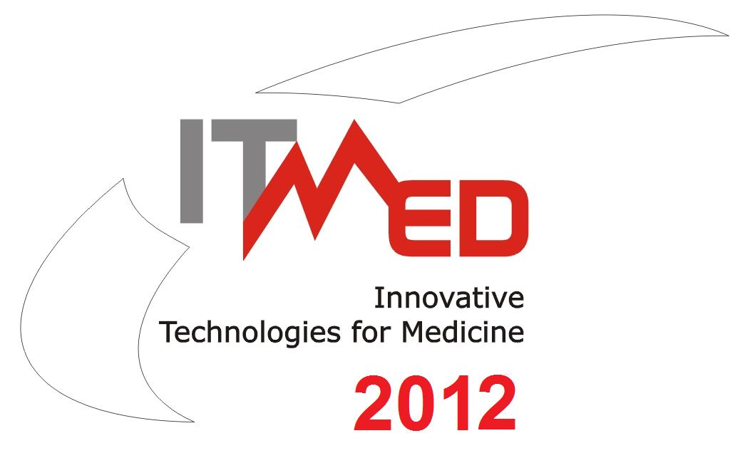
6th International Forum on
Innovative Technologies for Medicine
ITMED 2012

21 – 23 November 2012, Białystok

REGISTRATION FORM
General Information
Title |  | [ ] Mr [ ] Ms |  | Degree |  | [ ] MSc [ ] Ph.D. [ ] Prof.
Family Name |  |  |  | First Name
Job Title/position
Company/Institution
Address |  |  |  | City
Postcode |  |  |  | Country
Phone |  |  |  | Fax
E-mail
I’m interested in
[ ] participation in the SESSIONS and WORKSHOP
[ ] participation in the EXHIBITION  (as an exhibitor) |  |  | [ ] please, send me additional information (only for exhibitors)  [ ] I enclose form for exhibitors
I am interested in delivering: |  |  | [ ] Project/Business Proposal [ ] Abstract  [ ] (Oral) Presentation [ ] Poster
Title of Project/Business Proposal/Abstract/Oral Presentation/Poster (in Polish and English)

 | Keywords according to the Conference scope (max 3):
[ ] I enclose Project/Business Proposal Form
[ ] I enclose Abstract Form
[ ] I enclose Poster
Payments
[ ] 100 EUR per person, including VAT (before 21. 09.2012)  [ ] 150 EUR per person, including VAT (before 21.10.2012)  [ ] 200 EUR per person, including VAT (after 21.10.2012) |  |  |  |  | [ ] please, send me the proforma invoice
All registration payments should be made by bank transfer (please enclose a copy) to:
Innovative Eastern Poland Association, 5/303, Generała Władysława Andersa Str., 15-124 Białystok,
at SBR Bank O/Białystok, account number: 12 8769 0002 0390 9032 2000 0010, SWIFT Code: POLUPLPR
The conference fee covers: ● participation in all sessions ● conference materials ● coffee breaks ● lunch ● the catalog of 6th Innovative Technologies for Medicine ITMED 2012 ● participation in Forum Dinner
I agree to have my personal data processed for The Forum purposes in accordance with the act about the Personal Details Protection Act of 29 August 1997 (Journal of Laws [Dz.U] No. 133, item 883).
The Registration Form should be send before November 2, 2012 r. by email to: itmed2012@ipw.org.pl

Secretariat:
Marlena Suchcicka (Coordinator), Mariusz Warszycki (Forum Secretariat)
Innovative Eastern Poland Association
303/5, Generała, Władysława Andersa str., 15-124 Białystok
tel./fax: +48 85 675 00 95, mob: +48 728 958 050, e-mail: itmed2012@ipw.org.pl
website: www.ipw.org.pl, www.bestofeast.mwci.eu, skype: innowacyjna.polska.wschodnia

