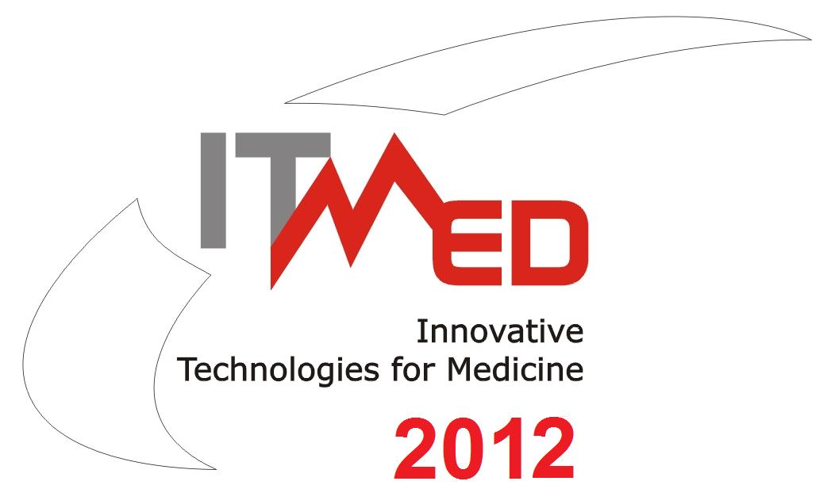
6th International Forum on
Innovative Technologies for Medicine
ITMED 2012

21 – 23 November 2012, Białystok

ABSTRACT
AUTHOR
Title, first name, surname
COMPANY/ORGANIZATION
Name and address
TITLE OF PROJECT (in Polish and English)
ABSTRACT (maximum 1200 characters)
KEY WORDS
CONTACT PERSON
Forname and surname
Contact details (e-mail, phone)
The Abstract should be send before October 26, 2012 r. by email to: itmed2012@ipw.org.pl

Secretariat:
Marlena Suchcicka (Coordinator), Mariusz Warszycki (Forum Secretariat)
Innovative Eastern Poland Association
303/5, Generała, Władysława Andersa str., 15-124 Białystok
tel./fax: +48 85 675 00 95, mob: +48 728 958 050, e-mail: itmed2012@ipw.org.pl
website: www.ipw.org.pl, www.bestofeast.mwci.eu, skype: innowacyjna.polska.wschodnia

