 |  |  |  | 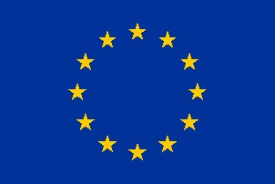  
DIASPORA WORKSHOP ON QUANTUM TECHNOLOGIES
21 November 2017, Minsk, Belarus
Venue: TBC
REGISTRATION FORM

Personal Information
Title (Ms., Mr., Prof., Dr.)
Family Name
First Name
Position
Organisation
Address
Country
Contact telephone number
Contact e-mail address
Form of participation |  | With presentation Without presentation
Topic of presentation
Itinerary (for diaspora representatives only)
Date of arrival to Minsk and preferable flight number: |  |  | Date of departure from Minsk and preferable flight number:
I need accommodation | Yes Number of nights: Starting from:  No

Please, return the filled-in registration form at the e-mail address: registration@belisa.org.by not later than
for diaspora representatives – 1 October 2017
for local participants willing to present their topic of research – 1 October 2017
for local participants without presentation – 3 November 2017
The earlier informal notification of organizers about the intention to take part in the Workshop by EU participants is extremely appreciated. Thank you in advance!

