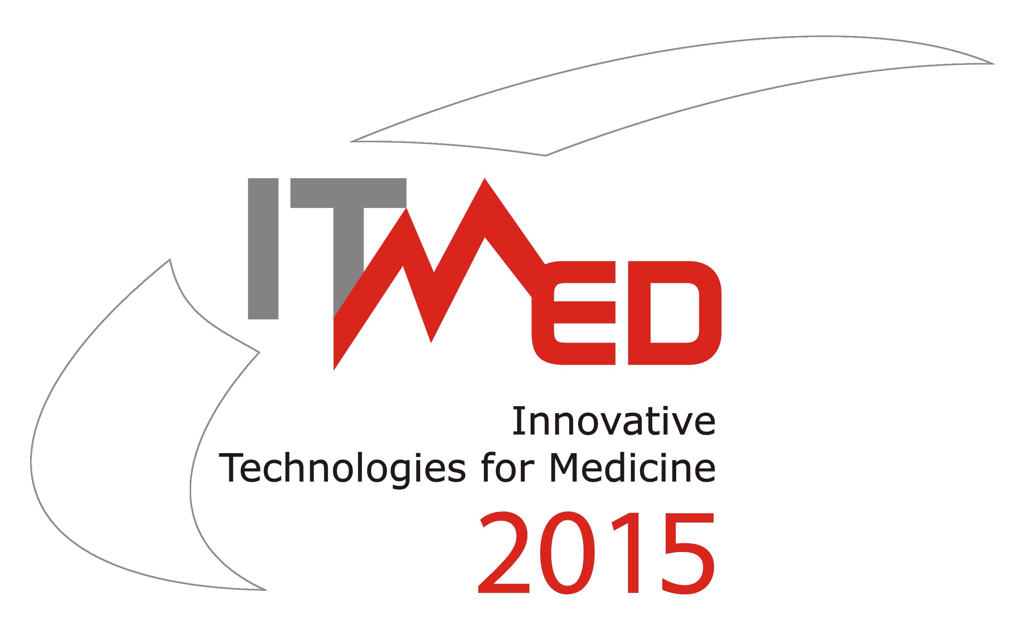
9th International Forum on
Innovative Technologies for Medicine

3 – 5 December 2015, Suprasl

REGISTRATION FORM
General Information
Title |  | [ ] Mr [ ] Ms |  | Degree |  | [ ] MSc [ ] Ph.D. [ ] Prof.
Family Name |  |  |  | First Name
Job Title/position
Company/Institution
Address |  |  |  | City
Postcode |  |  |  | Country
Phone |  |  |  | Fax
E-mail
I’m interested in
[ ] participation in the SESSIONS
[ ] participation in the EXHIBITION  (as an exhibitor or sponsor) |  |  | [ ] Sponsor [ ] Exhibitor  [ ] Partner [ ] Mini
I am interested in delivering: |  |  | [ ] Project/Business Proposal [ ] Abstract  [ ] (Oral) Presentation [ ] Poster
Title of Project/Business Proposal/Abstract/Oral Presentation (in Polish and English)

 | Keywords according to the Conference scope (max 3):
[ ] I enclose Project/Business Proposal Form
[ ] I enclose Abstract Form
Payments
[ ] 100 EUR (400zł) per person, including VAT (before 30.09.2015)  [ ] 150 EUR (600zł) per person, including VAT (before 30.10.2015)  [ ] 200 EUR (800zł) per person, including VAT (after 30.10.2015) |  |  |  |  | [ ] please, send me the  proforma invoice
All registration payments should be made by bank transfer (please enclose a copy) to:
Innovative Eastern Poland Association, 5/303, Generała Władysława Andersa Str., 15-124 Białystok,
at SBR Bank O/Białystok, account number: 12 8769 0002 0390 9032 2000 0010, SWIFT Code: POLUPLPR
The conference fee covers: ● participation in all sessions ● conference materials ● coffee breaks ● lunch ● the catalog of 9th Innovative Technologies for Medicine ITMED 2015 ● participation in Forum Dinner
I agree to have my personal data processed for The Forum purposes in accordance with the act about the Personal Details Protection Act of 29 August 1997 (Journal of Laws [Dz.U] No. 133, item 883).

The Registration Form should be send before November 10, 2015 r. by email to: itmed2015@ipw.org.pl

Secretariat: Innovative Eastern Poland Association
303/5, Generała, Władysława Andersa str., 15-124 Białystok
tel./fax: +48 85 675 00 95, mob: +48 728 958 050, e-mail: itmed2015@ipw.org.pl
website: www.itmed.mwci.eu, skype: innowacyjna.polska.wschodnia

