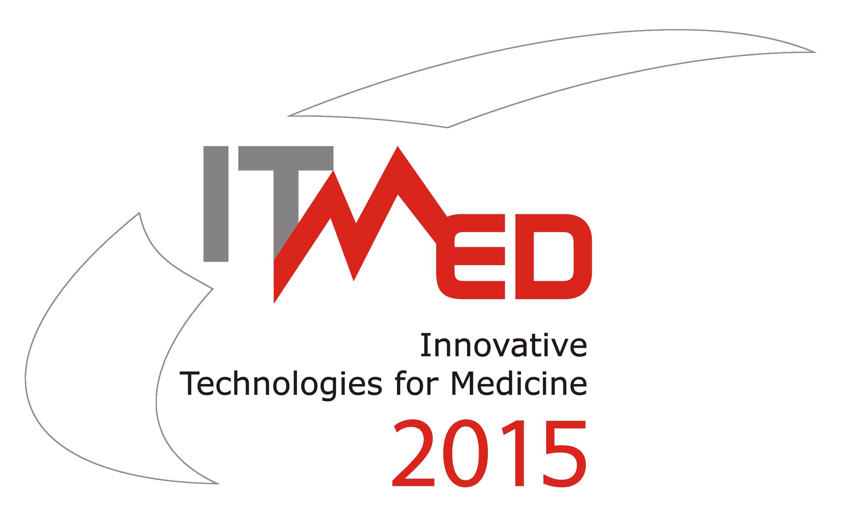
9th International Forum on
Innovative Technologies for Medicine

3 – 5 December 2015, Suprasl

PRELIMINARY BUSINESS/PROJECT PROPOSAL
Name of Institution
Department
Address | Street and No
Address | City and Zip code
Address | Country
Address | Tel./Fax
Address | E-mail/web site
Type of institution | ◻ University ◻ Research Institute ◻ Int’l Organization  ◻ Consultancy ◻ Public Administration ◻ Large Industry  ◻ SME ◻ Other: ................................................................................
Additional information | Established | Number of employees |  | Experience in international  co-operation |  | Approx. turnover in thousands of Euro
 |  |  |  |  |  | 2012 | 2013 | 2014
Additional information |  |  |  | ◻ yes ◻ no
Main subject of  activity | Key words (max. 3)
Institution profile | Please give a brief description of area of expertise  (including core business, products/services and key customers if relevant)
Contact person | Forename and surname
Contact person | Degree and position
Contact person | Address
Contact person | Tel./Fax
Contact person | E-mail/web site
Information on your project/  technology/  product | Title of Project (in Polish and English)
Information on your project/  technology/  product | Stage of your project/technology/product:
Information on your project/  technology/  product | ◻ Initial idea ◻ Feasibility study ◻ Definition phase  ◻ Development has been started ◻ Full exploitation  ◻ Other: ..................................................................................................................
 | Describe you project/technology/product idea briefly (maximum 3000 characters):
Type of  sought partner | ◻ University ◻ Research Institute ◻ Int’l Organization  ◻ Consultancy ◻ Public Administration ◻ Large Industry  ◻ SME ◻ Other: ......................................................................
Suggested contribution
from sought partner
 | Please give a brief description of the area of expertise
Name and address of a Polish* institution/company/organization you co-operate with
Name, telephone and fax numbers, e-mail address of a contact person

*Polish participants should give the names of partners from Eastern Europe

Please fill out this form and return
before November 10, 2015 by e-mail to: itmed2015@ipw.org.pl

Secretariat:
Innovative Eastern Poland Association
303/5, Generała, Władysława Andersa str., 15-124 Białystok
tel./fax: +48 85 675 00 95, mob: +48 728 958 050, e-mail: itmed2015@ipw.org.pl
website: www.itmed.mwci.eu, skype: innowacyjna.polska.wschodnia

