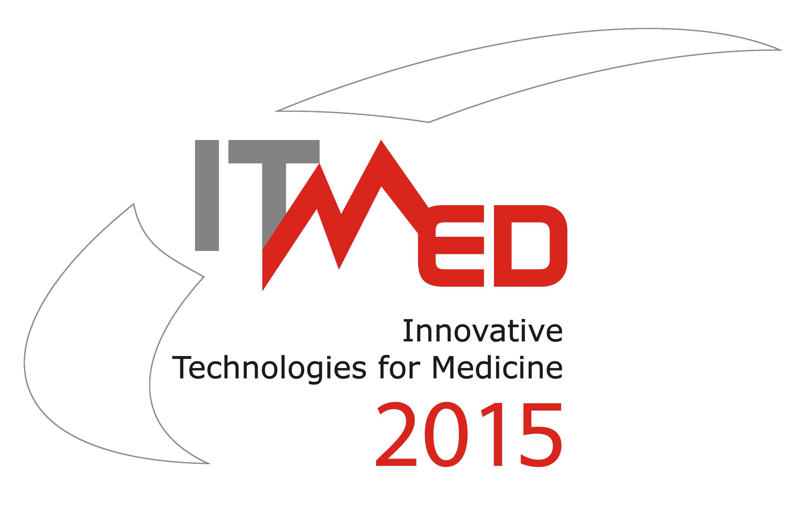

9th International Forum on
Innovative Technologies for Medicine
4
3– 5 December 2015, Suprasl

ABSTRACT
AUTHOR
First name, surname
COMPANY/ORGANIZATION
Name and address
NAME OF PROJECT
(in Polish and English)
ABSTRACT (maximum 1200 characters)
KEY WORDS
CONTACT WITH AUTHOR | Phone:  E-mail:
The Abstract should be send before November 10, 2015 r. by email to: itmed2015@ipw.org.pl

Secretariat:
Innovative Eastern Poland Association
303/5, Generała, Władysława Andersa str., 15-124 Białystok
tel./fax: +48 85 675 00 95, mob: +48 728 958 050, e-mail: itmed2015@ipw.org.pl
website: www.itmed.mwci.eu, skype: innowacyjna.polska.wschodnia

